**Lab Setup:**

**XAMPP** is a free and open-source cross-platform web server stack package developed by Apache Friends. It provides a local server environment for web development and testing purposes. XAMPP is widely used by developers to create and test dynamic web applications on a local machine before deploying them to a live server.

Download and install XAMPP from the following location: <https://www.apachefriends.org/>

XAMPP Lab Setup: Navigate to htdocs Directory: Open the htdocs folder located in your XAMPP installation directory (e.g., C:\xampp\htdocs on Windows). This is where you will store your web application files. Create a New Project Folder Called Lab1 inside the htdocs folder. Place your application code files in this folder.

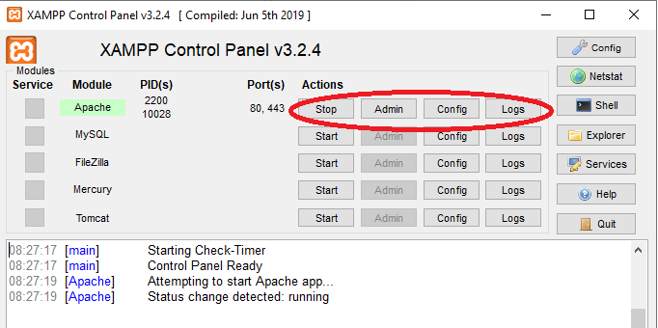

**ZAP (Zed Attack Proxy)** is an open-source web application security scanner, originally developed by the Open Web Application Security Project (OWASP). It is designed to help developers and security professionals identify vulnerabilities in web applications.

Download and install ZAP from the following location: https://www.zaproxy.org/

I will demo both XAMPP and ZAP at the beginning of the Lab.

**Objective:** The aim of this lab is to identify and document where 1: input validation is insufficient and 2: identify and record XSS vulnerability’s

**Review:** [**https://www.php.net/manual/en/function.filter-var.php**](https://www.php.net/manual/en/function.filter-var.php) **to help with mitigation in input validation.**

Lab 2 Finding 1

|  |  |  |
| --- | --- | --- |
| **Date** | **Attack** | **Result** |
| 24/09/2024 | **HTTP Request:** POST  **Location:** Https://localhost/lab/Lab.php  **Parameter:** name  **Payload** name=9999999999999999999999999999999999999999999999999999999999999999999999 | **Input validation:**  On the length of the inputted string not validated on the server-side code.  Screen capture of the reflected string places here  FINDING: Insufficient input Validation |
| **Mitigation and analysis** | | |
|  | | |

Lab 2 Finding 2

|  |  |  |
| --- | --- | --- |
| **Date** | **Attack** | **Result** |
|  |  |  |
| **Mitigation and Analysis** | | |
|  | | |

Lab 2 Finding 3

|  |  |  |
| --- | --- | --- |
| **Date** | **Attack** | **Result** |
|  |  | FINDING:XXXXXXXXXXXXXXXXXXXXX |
| **Mitigation** | | |
|  | | |